Project Design Phase-II
Technology Stack (Architecture & Stack)

Date | 31 May 2025
Team ID | LTVIP2025TMID56096
Project Name | Flightfider:Navigating your Air Travel Options
Maximum Marks | 4 Marks

Technical Architecture:
The Deliverable shall include the architectural diagram as below and the information as per the table1 & table 2
Example: Order processing during pandemics for offline mode
Reference: https://developer.ibm.com/patterns/ai-powered-backend-system-for-order-processing-during-pandemics/
Guidelines:
Include all the processes (As an application logic / Technology Block)
Provide infrastructural demarcation (Local / Cloud)
Indicate external interfaces (third party API’s etc.)
Indicate Data Storage components / services
Indicate interface to machine learning models (if applicable)
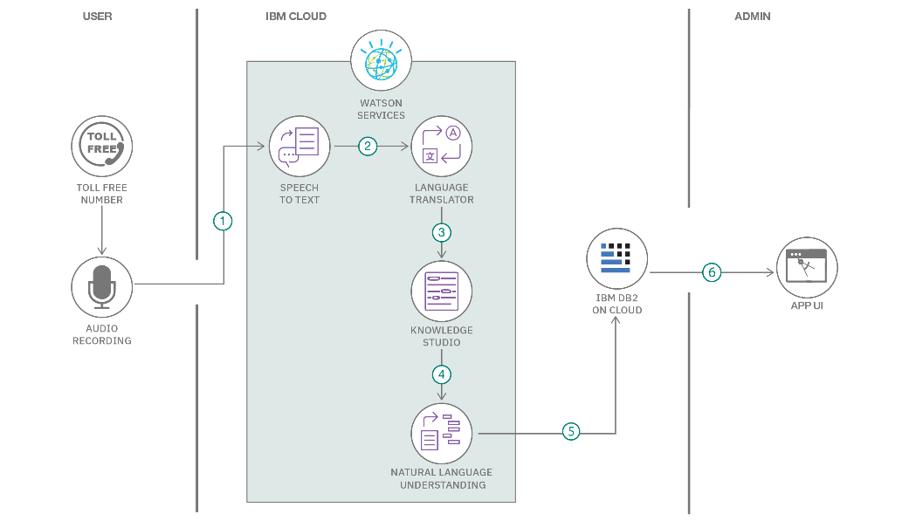

Table-1 : Components & Technologies:
S.No | Component | Description | Technology
 | User Interface | Frontend pages for users to search, filter, and book flights | HTML, CSS, JavaScript / Angular Js / React Js
 | Search & Filter Engine | Enables users to search flights by location, date, class, airline, and price. | React.js state, MongoDB queries,
 | Flight Listings | Shows available flights with details, | React.js,CSS
 | Booking System | Handles passenger detail forms and booking confirmation | React Forms, Express.js, MongoDB
 | Authentication & Access | Provides login/signup for users and admins
 | Admin Dashboard | Allows admin to add/edit/delete flights and manage bookings | React.js, Express.js, MongoDB, JWT
 | Backend API | Handles all logic for bookings, users, flights, and filters | Node.js, Express.js
 | Database Layer | Stores flight data, bookings, and user/admin credentials | MongoDB, Mongoose
 | Version Control | Manages codebase and team collaboration | Git, GitHub
 | Deployment | Hosts the frontend, backend, and database for live access | Render, Netlify, MongoDB Atlas
 | Project Management Tools | Organizes tasks, designs, and communication during development | Trello, Notion, Figma, Google Docs/Meet

Table-2: Application Characteristics:
S.No | Characteristics | Description | Technology
 | Open-Source Frameworks | Uses open-source tools like React.js, Node.js, Express.js, MongoDB, and CSS to ensure cost efficiency and community-driven support. | React.js, Node.js, Express.js, MongoDB, Tailwind CSS
 | Security Implementation | Implements JWT for authentication, bcrypt for password encryption, HTTPS for secure data transfer, and input validation to prevent common attacks. | JWT, bcrypt.js, Helmet.js, HTTPS, Express-validator
 | Scalable Architecture | Built using a modular MERN stack (MongoDB, Express, React, Node.js) with RESTful APIs, allowing easy scalability by adding microservices if needed. | MERN stack, RESTful APIs, Microservices
 | Availability | Deployed on cloud platforms like Render or Vercel with MongoDB Atlas for high uptime, ensuring 24/7 access and reliable performance | Render, Vercel, MongoDB Atlas
 | Performance | Designed with optimized queries, React’s virtual DOM, backend caching (if needed), and load balancing support for handling multiple requests fast. | React Virtual DOM, MongoDB Indexing, Node.js, Caching

References:
https://c4model.com/
https://developer.ibm.com/patterns/online-order-processing-system-during-pandemic/
https://www.ibm.com/cloud/architecture
https://aws.amazon.com/architecture
https://medium.com/the-internal-startup/how-to-draw-useful-technical-architecture-diagrams-2d20c9fda90d

